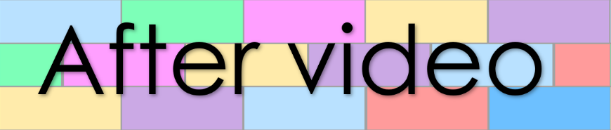
Chapter 11
Lesson 239
- Match the prefixes with their meanings

fore
against
de
inter
middle
in
cause to
pre
between
im
in
before
opposite
mid
dis
en
anti
em

- Fill the gaps with a time phrase
these past few days | Later this year | seldom
- She misses school.
- , the circus will arrive in town.
- I’ve been very busy .

Book 43 – The Weimer Republic

- Answer the following questions

(Answer all questions with full sentences)
- Who did the German people blame World War 1 on?

- Why did Wilhelm ll abdicate his throne?

- What were the two political parties who established the new government in Weimer?

- Did the new government like free markets or favour government control?

- What problem did Germany have with their neighbouring countries after World War 1?

- What did France do when Germany failed to keep up with its payments?

- After France occupied Germany’s coal and iron mines, how did Germany get money to pay their debts to other countries?

- What did the German people do once they lost faith in the German Mark?

- Which country did Germany establish a strong trade partnership with after their disastrous printing experiment?

- What was the cause to Germany’s second economic crisis?

- After the country’s second economic crash within ten years, how did the German people feel toward the government, and what did they now yearn for?

- Germany suffered greatly due to the payments demanded on them by their neighbouring countries. Do you think these payments were fair? Explain your answer.

- What type of economic crisis do you think will be worse: Germany’s first crisis when the country had too much money or their second crisis when they had too little money? Explain your answer.

- Write the meaning to each of the following words

Antiauthoritarian
Discontent
Mutinies
Conducted
Abdicate
Relinquish
Constitution
Tenuous
Anticapitalistic
Reparations
Incite
Occupation
Deserted
Deindustrialization
Implement
Demonetise
Restraint
Impoverished
Excessive
Flourish
Prosperity
Antibureaucratic
Destabilise
Indoctrinate

