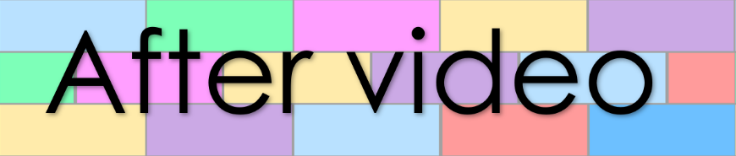
Word Wall
Lesson 14
- Match the sounds with their pictures
ng
ch
dr
tr
sh







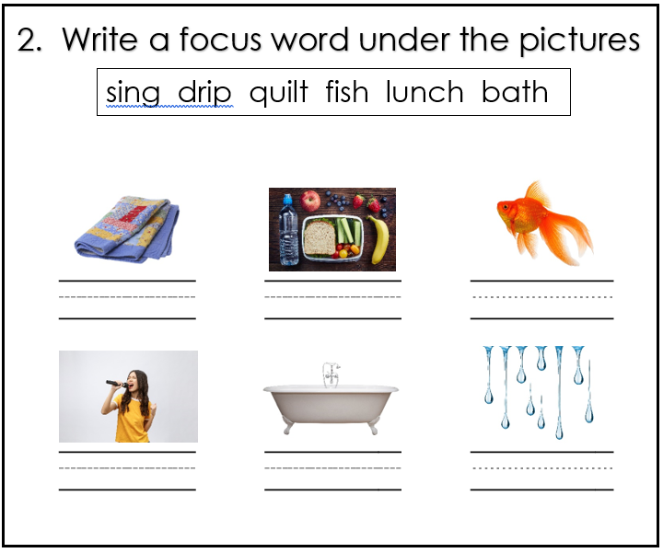

- Match the auxiliary verbs with their pronoun

are
am
is

they
he
we
you
I
she

- Match the words with their grammar term

jog
noun

mad
adjective

drum
verb

