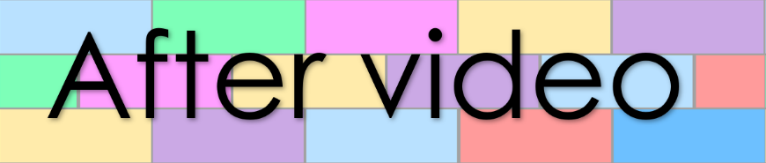
Goal 22
Lesson 74
1. match the words with their grammar term

between
preposition
insure
advise
among
noun
affect
verb
assure
effect
ensure
advice
person
whose
2. match the question starters with their meaning
object
who
reason
what
- Write sentences under the pictures
person’s object
when
ability / process
why

time
how

3. fill the gaps with the correct question starter
whose | who | what | when | why | how
- is meeting us at the library?
- will the train arrive at our station?
- cat is stuck in our tree?
- is there rubbish on the road?
- can you whistle?
- vegetables are you growing?

4. Sentence building

Rewrite the below sentence with these words included:
at my brother, angry, aggressively, scared, at the farm, last weekend

A duck quacks.

Rewrite the below sentence with these words included:
our, down a hill, spare, speedily, just now

A tire rolled.

- Sentence labelling
Label the parts of speech in the below sentences
Without my special shoes, I never play well in our soccer matches.

The salesman was certain the owner would meet us here later today.

