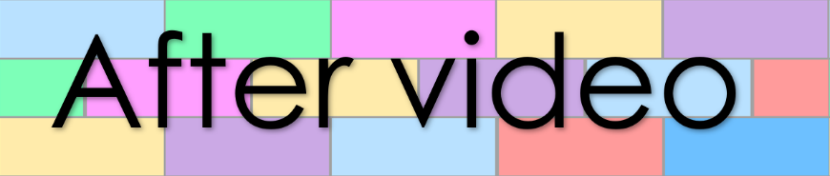
Part B
Chapter 1
Lesson 35
Book 5 – A slug on a sled

- Number the sentences in the order they appear
in the story in the story

The stick stuns the slug.
The slug steps off the sled.
The bug asks, “Was it fun?”
The sled is black and red.
The stick snaps and hits the slug.
He slaps the sled, but the sled still did not stop.
A slug is on a sled.
The sled slams into a big stick.
The sled slid a long a hill. It was fast.
He felt stiff and slick.
It spun and the slug felt sick.
And the bug gives the slug a snack.
The sled smacks into a rock, but the sled did not stop.
He spots a big bug, and the sled stops next to the bug.
“Stop!” The slug yells, but the sled did not stop.

- Fill the gaps in the sentences

The stuns the .
The sled is and .
It and the slug felt .
He felt and .
And the gives the slug a .
A slug is on a .
The stick and hits the .
The slug off the sled.

