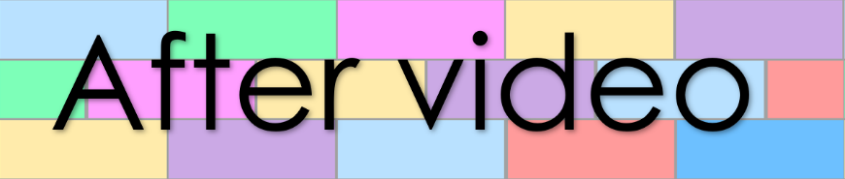
Goal 22
Lesson 58
- Match the prefixes with their meanings

em
in
pre
cause to
mid
before
in

opposite
de
between
middle
en
im
fore
inter
can’t | need | may not
- Fill the gaps with a modal verb
- We bring our pets with us. (permission)
- She stay awake any longer. (ability)
- Cake sugar, flour and eggs. (necessity)

could want shall can
1.
2.
3.
4.
- Write a sentence with each of the following words

