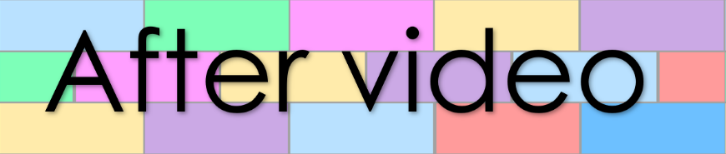
Chapter 2
Lesson 75
Book 12 – A witch did a bad spell

- Number the sentences in the order they appear
in the story in the story

The spell zaps her lunch. It cracks her dishes and snaps her bench.
She snaps a quill and puts it in the big pot.
She pashes a frog and puts it in the big pot.
Her thick spell spills from the pot. The witch gags from the smell.
A witch is in her shack.
Her cat jumps on the bench. The cat licks the cracked dishes and munches on the witch’s lunch.
She shuts the pot with the lid.
She yells and quacks and taps the pot with her hands.
The witch snatches her cat, and she walks to the bath.
The shack fills with a bad stench. Her shack is a big mess, and she is wet.
She chops a radish and puts it in a big pot.
She mashes a fig and puts it in the big pot.
The pot jumps and bumps. Crash, crunch. Her spell goes bad.
The cat smells as bad as her. “We need a wash,” The witch quips.

- Fill the gaps in the sentences

A witch is in her .
She chops a and puts it in a big pot. She a fig and puts it in the big pot.
She snaps a and puts it in the big pot. She a frog and puts it in the big pot.
She the pot with the lid. She yells and and taps the pot with her .
The pot jumps and . Crash, . Her spell goes bad.
The spell zaps her . It cracks her and snaps her bench.
The shack fills with a bad . Her shack is a big , and she is wet.
Her thick spell from the pot. The gags from the smell.
Her cat jumps on the . The cat licks the dishes and on the witch’s lunch.
The cat as bad as her. “We need a ,” The witch quips.
The witch her cat, and she walks to the .

