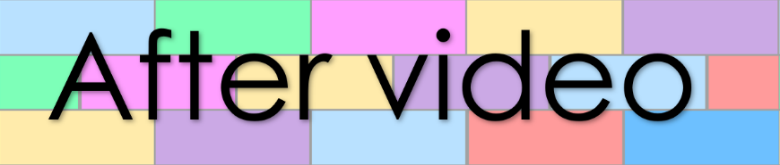
Chapter 6
Lesson 158
Book 26 – A clown’s show

- Answer the following questions
- Who are the kids watching?

- Describe what the stage looks like.

- Describe what the clown looks like.

- Why does a boy in the crowd cry?

- Who blew the clown’s balloon?

- What animal did the clown twist the balloon into?

- What does the clown shout as he gives the balloon to the boy?

- What do the mums and dads place in the clown’s box?

- Why do you think the mums and dads give the clown coins? (Answer with a full sentence)

- Why might a person choose not to give the clown any coins? (Answer with a full sentence)

- Fill the gaps in the sentences

In a small away from the city, a clown dances on a , wooden stage. The had a big, bright red wig, big, yellow shoes and baggy, pants.
A boy at the front of the plays with a balloon. The balloon pops and the begins to cry. The clown freezes his dance. He looks at the boy with a .
The smiles and dances. As he dances, he twists the balloon into shapes until it looks like a . He gives the cow-balloon to the boy while , “Mooo.”
The clown and some mum and dads approach the stage and place in the box on the side of the stage.

