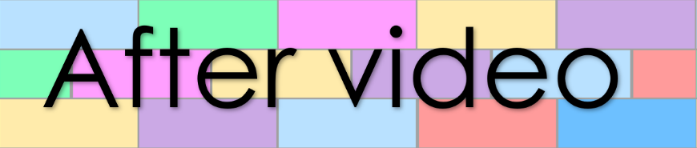
Goal 22
Lesson 66
- Correct the following misspelt words

- Concieted 2. Conscience 3. Feind

4. liesurable 5. Faset 6. hallucinojen

- Change the questions to statements

- Can we have more soup?

- Shall our parents join us?

- May I try these shoes?

- Change the statements to questions
- Our baby can’t walk.

- The customers may change their table.

- We couldn’t find the lost cat.

- Write sentences under the pictures

Rewrite the below sentence with these words included:
clumsily, my friend, last week, new, expensive,
outside the shopping mall
4. Sentence building

Wendy lost her handbag.

Rewrite the below sentence with these words included:
In front of a crowd, awkwardly, small, tired, old, daily

A clown dances on a stage

5. Sentence labelling
Label the parts of speech in the below sentences

Last night, during a movie, my father scared us by banging on the front
door.

With my friends at my side, we walk to the haunted house across the road.

