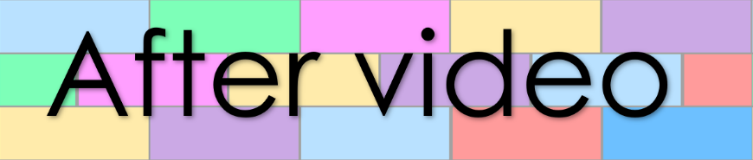
Word Wall
Lesson 44

- Syllabicate the below words

holiday mindfulness aquatic
terrific plentiful fantastic
worrisome blatantly copious

2. change the below adjectives to a superlative | er | est
colourful

dark

bright

bland




- Write sentences under the pictures
than
er
comparative phrase
object
auxiliary verb
subject

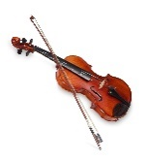


than
er
comparative phrase
object
auxiliary verb
subject

